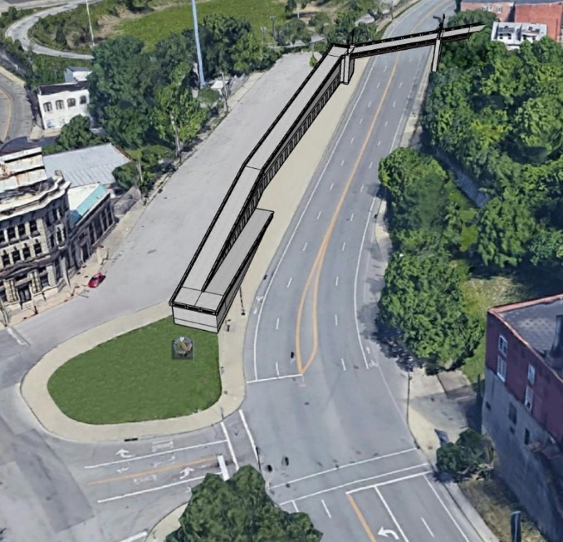
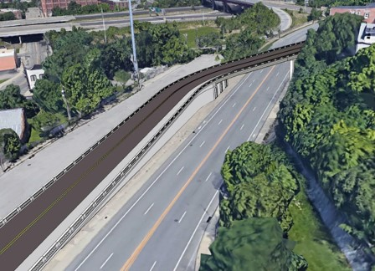
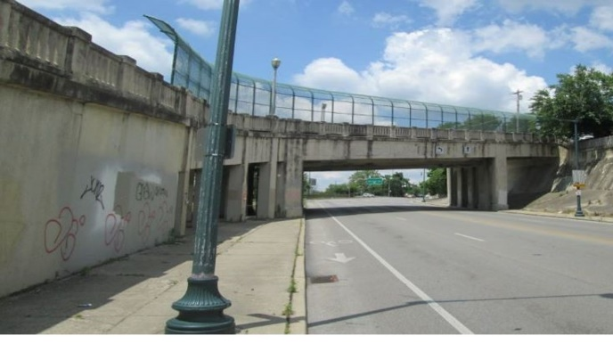
Brighton Approach Bridge Alternative Comparison
Alt 1: Maintain Existing Bridge
Positives | Negatives
Maintains direct connection | Structural deficiency remains
No impact to historically eligible bridge | Poor pedestrian and bike access on Central Parkway
No construction cost | Poor vertical clearance for trucks on Central Parkway
 | High life-cycle costs for maintenance of deteriorating bridge
 | Remaining lifespan: 5 to 15 years
Alt 2: Replace with New Bridge for Vehicles & Pedestrians
Positives | Negatives
Fixes structural deficiencies | Adverse impact to historically eligible bridge
Maintains direct pedestrian and vehicle connection | High construction costs
Improves pedestrian and bike access on Central Parkway
Improves vertical clearance for trucks on Central Parkway
Low life-cycle costs for new bridge
Alt 3: Replace with New Pedestrian-Only Bridge
Positives | Negatives
Fixes structural deficiencies | Adverse impact to historically eligible bridge
Maintains direct pedestrian connection | Mid to high construction cost
Improves pedestrian and bike access on Central Parkway | Lose vehicle connection at Brighton Approach
Improves vertical clearance for trucks on Central Parkway | Reroutes existing traffic but volume is low
Low life-cycle costs
Alt 4: Remove Existing Bridge & Build ADA Pathway
Positives | Negatives
Fixes structural deficiencies | Adverse impact to historically eligible bridge
Creates ADA-friendly pedestrian connection at Brighton Place | Mid to high cost
Improves pedestrian and bike access on Central Parkway | Lose vehicle connection at Brighton
Improves vertical clearance for trucks on Central Parkway
Low construction cost
Low life-cycle costs
